CIS 466

Systems Development ASP.Net Project

Summer 2018

Restaurant Menu User Guide

Kaiba Redux Team:

**Imran Parvez**

**Jose Rodriguez**

**Kyle Tejada**

**Nathan Wong**

**Steve Mori**

**Vincent Luu**

**Table of Contents**

**1 INTRODUCTION** 3

**2 PREREQUISITES** 3

**2.1 Install Visual Studio, The Existing API, and .Net Core 2.1** 3

**2.2 Install SQL Server 2017 Standard Edition** 4

**3 CONFIGURATIONS** 11

**3.1 Establishing a Connection from the KaibaReduxAPI to SQL Server** 11

**3.2 Configuring the KaibaRedux Database in SQL Server** 12

**3.3 Reset the KaibaRedux Database in SQL Server** 14

**4 APPLICATION** 15

**4.1 Running the Kaiba Redux API** 15

**4.2 Create a New Menu in the Kaiba Redux API** 16

**4.3 Read a New Menu in the API** 16

**4.4 Update and Editing Existing Items** 17

**4.5 Delete Items from the Application Program Interface** 18

# **1 INTRODUCTION**

**ASP.NET** uses Microsoft’s Active Server Pages (ASP) technology used to design dynamic webpages and provides all the services that is required to build enterprises-level class server web applications. ASP.NET is part of a .NET framework in which allows access within the classes of the .NET environment. Applications can be coded in various languages compatible within Common Language Runtime (CLR) which enhances the further development of ASP.NET applications from CLR, type safety, and inheritance.

This documented guide further extends upon the step-by-step process of using ASP.NET on Visio Studio for Windows and provides a functional restaurant menu list indexing product using a connected SQL Server database. Additional information can be found within the **KaibaReduxAPI developer documentation.**

# **2 PREREQUISITES**

## **2.1 Install Visual Studio, The Existing API, and .Net Core 2.1**

Next, install Visual Studio here:

[https://www.visualstudio.com/thank-you-downloading-visual-studio/?sku=community&rel=15#](https://www.visualstudio.com/thank-you-downloading-visual-studio/?sku=community&rel=15)

Select **.NET Core cross-platform development** installation and click **Install**.

Add the existing web application program interface (API) from the **GitHub** repository named **KaibaReduxAPI** in the following steps:

1. Visit <https://github.com/USER-ERROR-42/KaibaReduxAPI>
2. Click on “**Clone or download”** and choose a method in the picture below
3. “**Open in Desktop”** if GitHub Desktop is preferred.

Install Guide GitHub Desktop:

<https://help.github.com/desktop/guides/contributing-to-projects/cloning-a-repository-from-github-to-github-desktop/> or **“Download ZIP”**

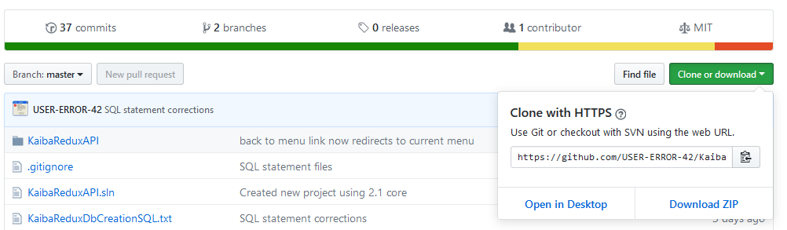

1. After the repository has been cloned or unzipped to a preferred location on your Windows PC open **“KaibaReduxAPI.sln”** to build the initial project in Visual Studio. An option to install additional extensions may be required. **Accept additional installs if required.**
2. **Install .NET Core 2.1 SDK or Later**

Download and install .NET SDK (Tested Ver. 2.1.302)

<https://www.microsoft.com/net/download/thank-you/dotnet-sdk-2.1.302-windows-x64-installer>

**\*Additional information about ASP.Net Core 2.1 and guide:**

<https://docs.microsoft.com/en-us/aspnet/core/?view=aspnetcore-2.1>

## **2.2 Install SQL Server 2017 Standard Edition**

Install SQL Server 2017 Standard Edition 32/64 bit, here:

<https://e5.onthehub.com/WebStore/Security/Signin.aspx?ws=330817f9-cb9b-e011-969d-0030487d8897&vsro=8&rurl=%2fWebStore%2fProductsByMajorVersionList.aspx%3fws%3d330817f9-cb9b-e011-969d-0030487d8897%26vsro%3d8>

Or Free Developer Edition SQL Server 2017: <https://www.microsoft.com/en-ca/sql-server/sql-server-downloads>

A CPP Student account will be required to download a free licensed copy

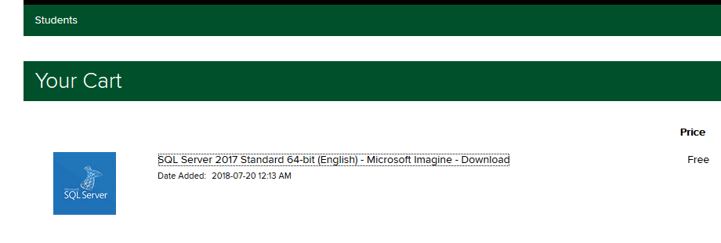

1. Open the **setup.exe** file in the parent directory of the DVD (en_sql_server_2017_standard_x64_dvd_11294407.iso file).
2. Run **System Configuration Checker** for compatibility.

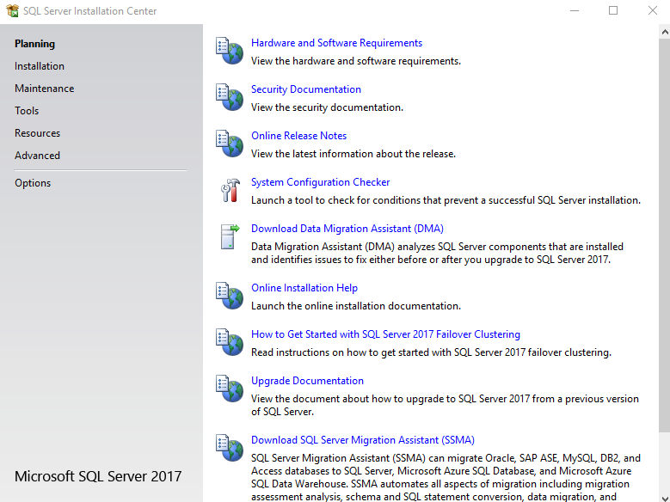

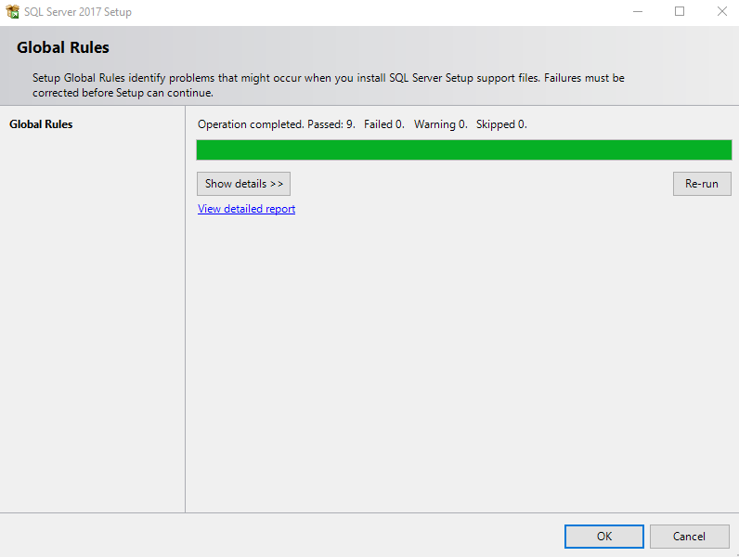

1. Click **“Installation”** on the left select **“New SQL Server stand-alone installation or add features to an existing installation”** if you receive an ERROR about SQL Server not able to update ignore and select “**Next”** 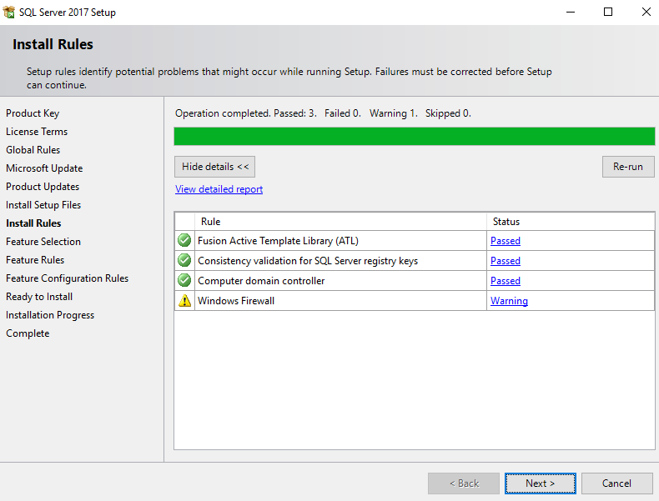
2. In the **Feature Selection** select everything EXCEPT **“PolyBase Query Service for External Data** (only runs on Oracle JRE 8)**”**

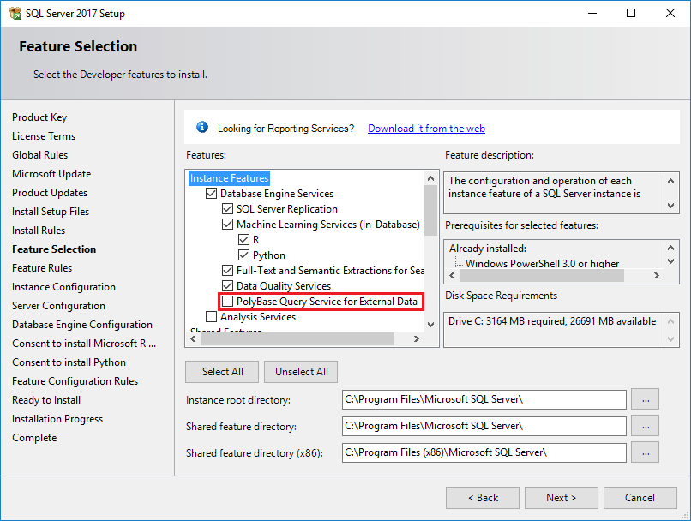

1. Install Java SE Runtime Environment 10.0.2 **Agree** to the terms and download at: <http://www.oracle.com/technetwork/java/javase/downloads/jre10-downloads-4417026.html>
2. Select **“Default Instance”** click on next

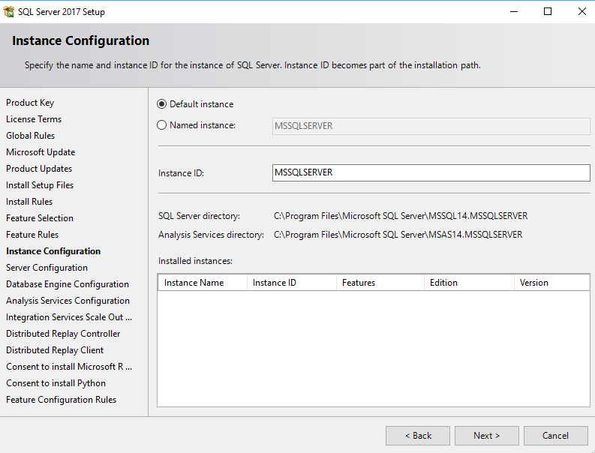

1. The screen below provides a summary of accounts that will be configured. Hit **Next**

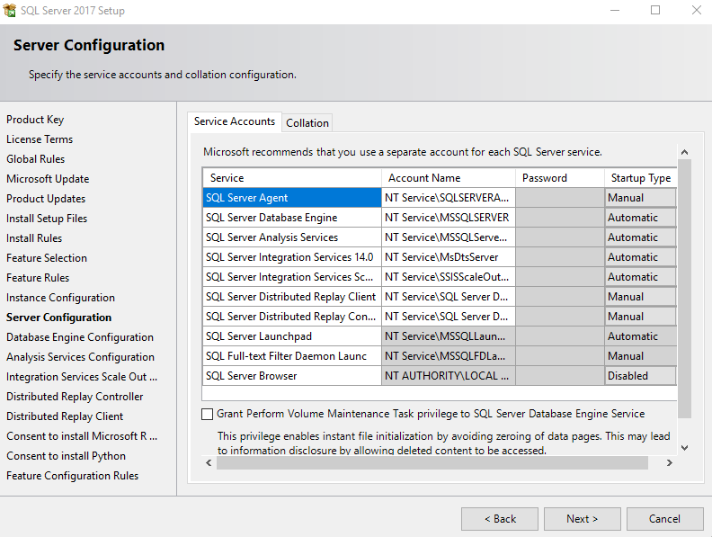

1. Make sure **“Windows authentication mode”** is selected. Click **“Add Current User”** and **Next**

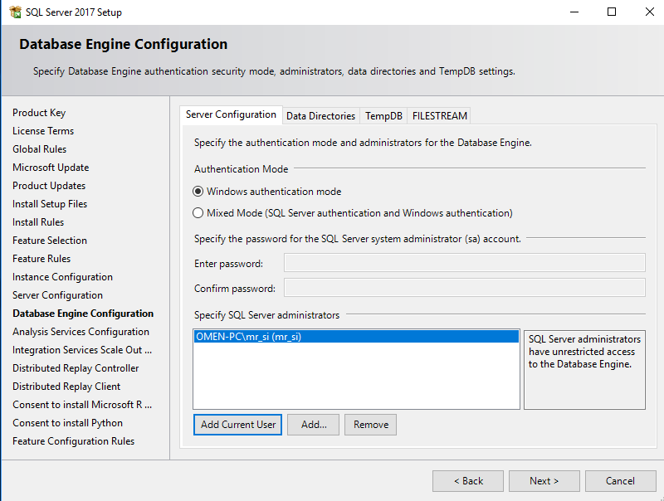

1. Make sure **“Multidimensional and Data Mining Mode”** is clicked in **“Analysis Services Configuration”** and click **“Add Current User”** again. Hit **Next**

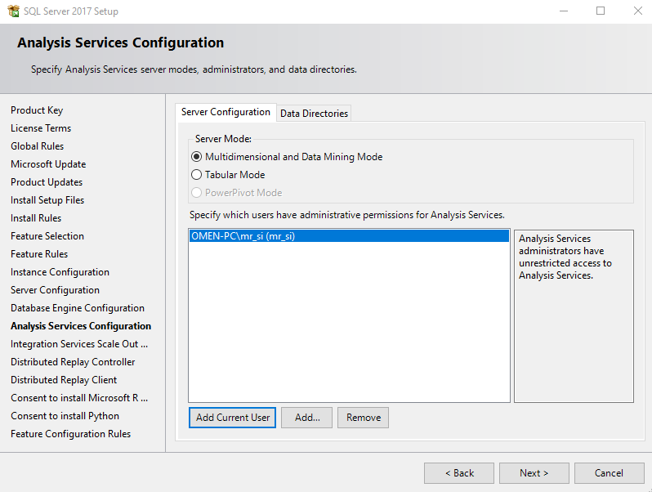

1. Click **Next (Controller names and end nodes may be blank)** until you reach **“Distributed Replay Controller”**
2. click **“Add Current User”** again **Agree** to terms and wait for the install to complete over several minutes.

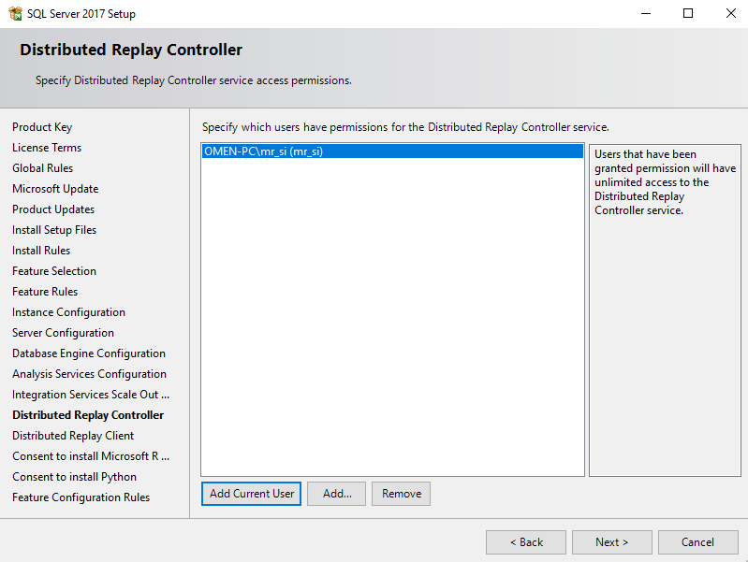

1. Download SQL Server Management Studio 17.8.1 or Later here:

<https://docs.microsoft.com/en-us/sql/ssms/download-sql-server-management-studio-ssms?view=sql-server-2017>

The same link is also provided in the SQL Server initial setup screen. Install. Done.

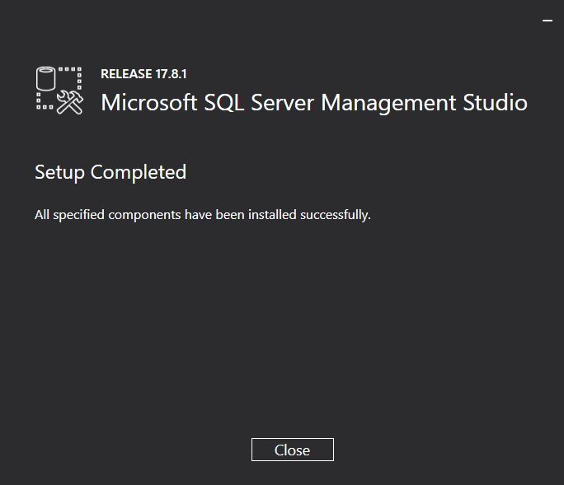

1. From the Start Menu open **“Microsoft SQL Server Management Studio”** and make note of your **“Server name”** click **“Connect”**

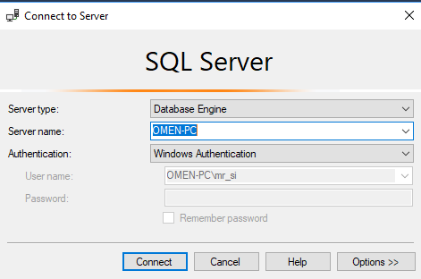

1. **Right clicking** on your Server and clicking **“Properties”** displaysyour server name as well. This is a crucial step and is covered in the next section.

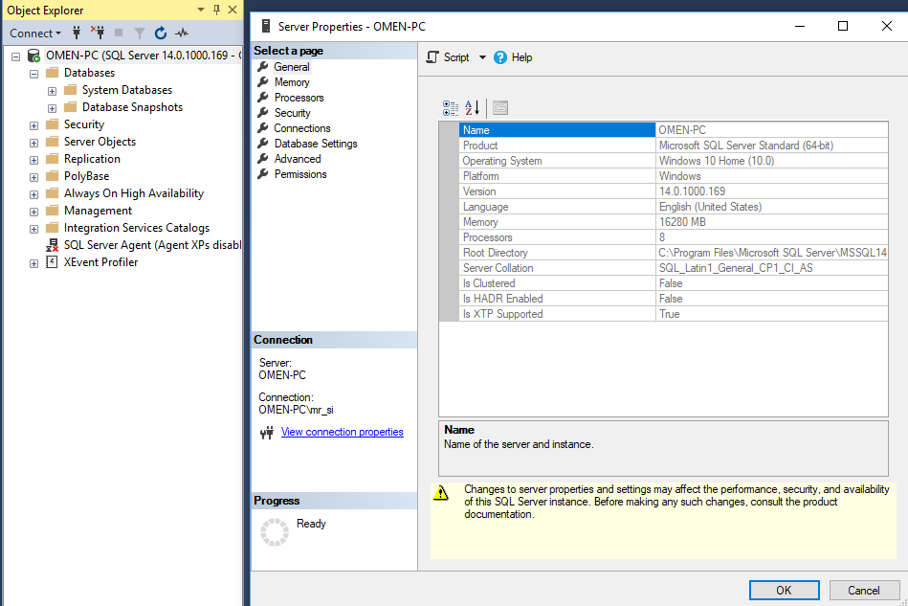

# **3 CONFIGURATIONS**

## **3.1 Establishing a Connection from the KaibaReduxAPI to SQL Server**

This step is **CRUCIAL** to have proper communication to your database which is dependent to your **Server name (Desktop Name)**

1. Refer to **section 2.1 Step 4**
2. Once Visual Studio has opened the **“KaibaReduxAPI.sln”** file go to the **“Solution Explorer”** taskbar on the right and open the **“Controllers”** folder
3. Open the **“DbAccessManagement.cs”** C# file and add your **Server name** from **section 2.2 Step 14**.
4. Edit after **“Data Source= “** and click the save icon on the top left

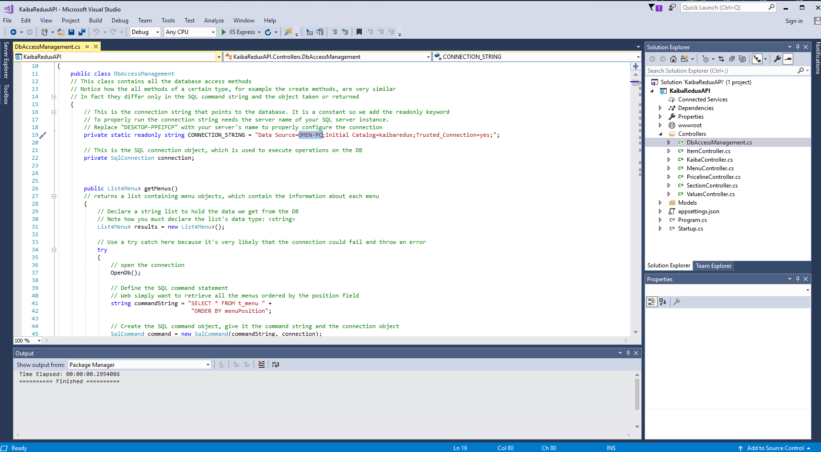

## **3.2 Configuring the KaibaRedux Database in SQL Server**

1. Open the **“KaibaReduxAPI”** folder and open **“Test Information reset SQL.txt”** and **select all** and **copy**

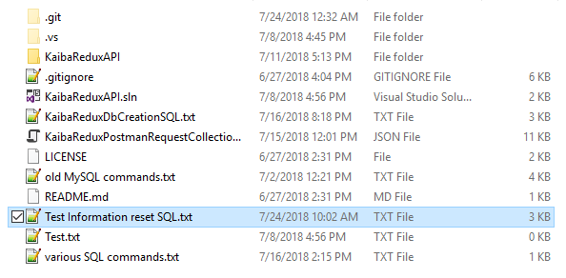

1. Open SQL Sever right click the **“Databases”** click **“New Database…”**
2. Name the database “kaibaredux”

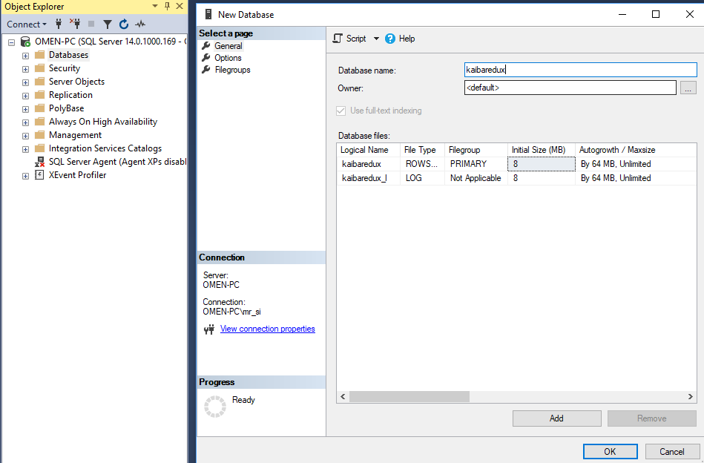

1. Right click the created **“kaibaredux”** database and click **“New Query”**
2. Paste the SQL commands from the text into the query
3. **click** **“Execute”** above

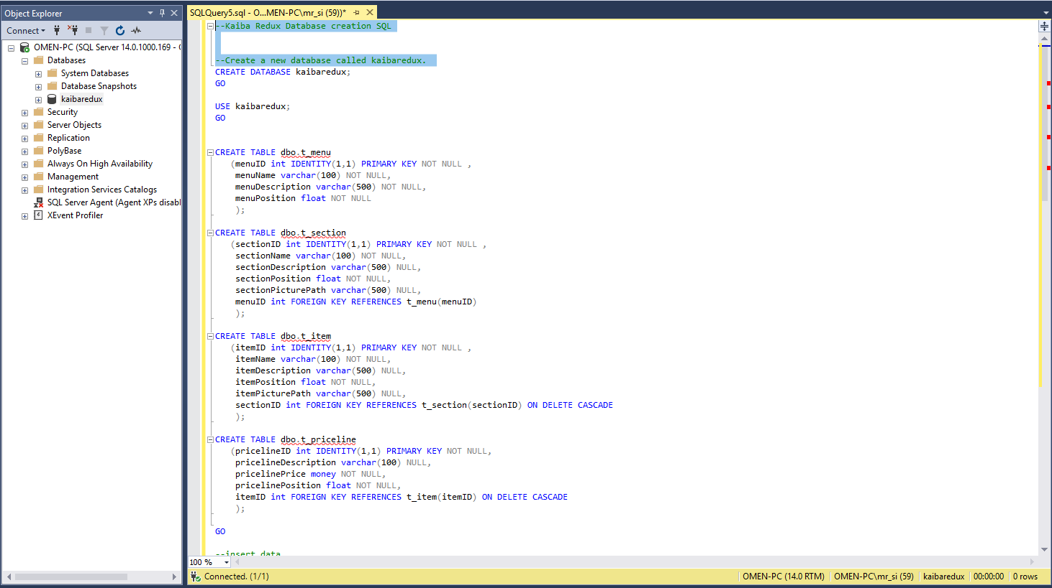

1. The database is properly created if the following is displayed with no errors below.

Do not panic if you have errors, most likely you have repeated this step in SQL Server. Redundant data entry is not allowed.

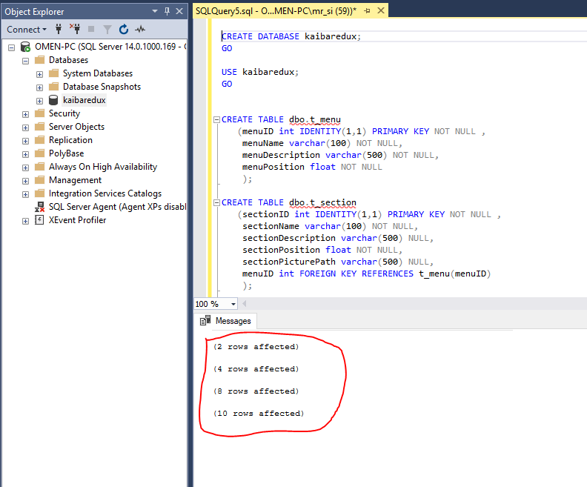

1. Simple SQL **SELECT** statements can display the table content

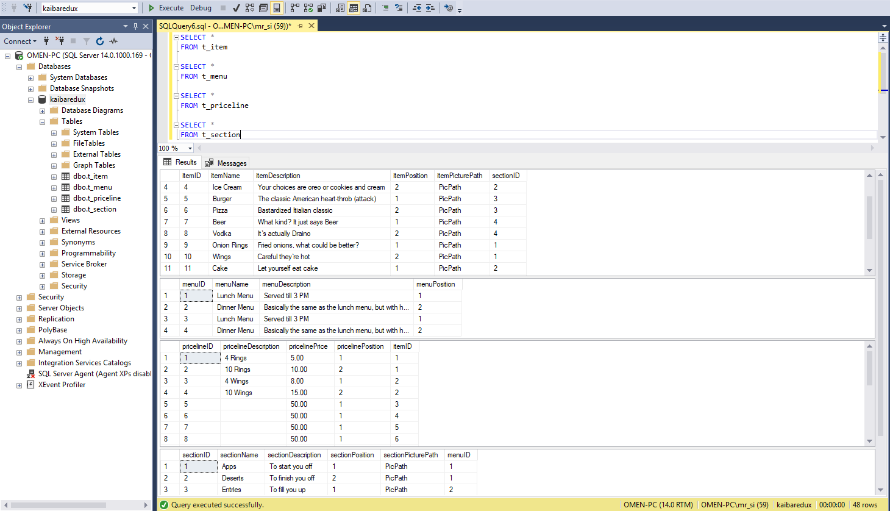

## **3.3 Resetting the KaibaRedux Database in SQL Server**

If for any reason data has been deleted from the SQL Server database, running the following reset SQL commands will restore the default data and remove any new data from the existing DB.

1. The SQL database reset commands can be found in **“KaibaReduxAPI”** folder in **“Test Information reset SQL.txt”**
2. Select **all** **the text** and repeat from **step 3** in **section 3.2**

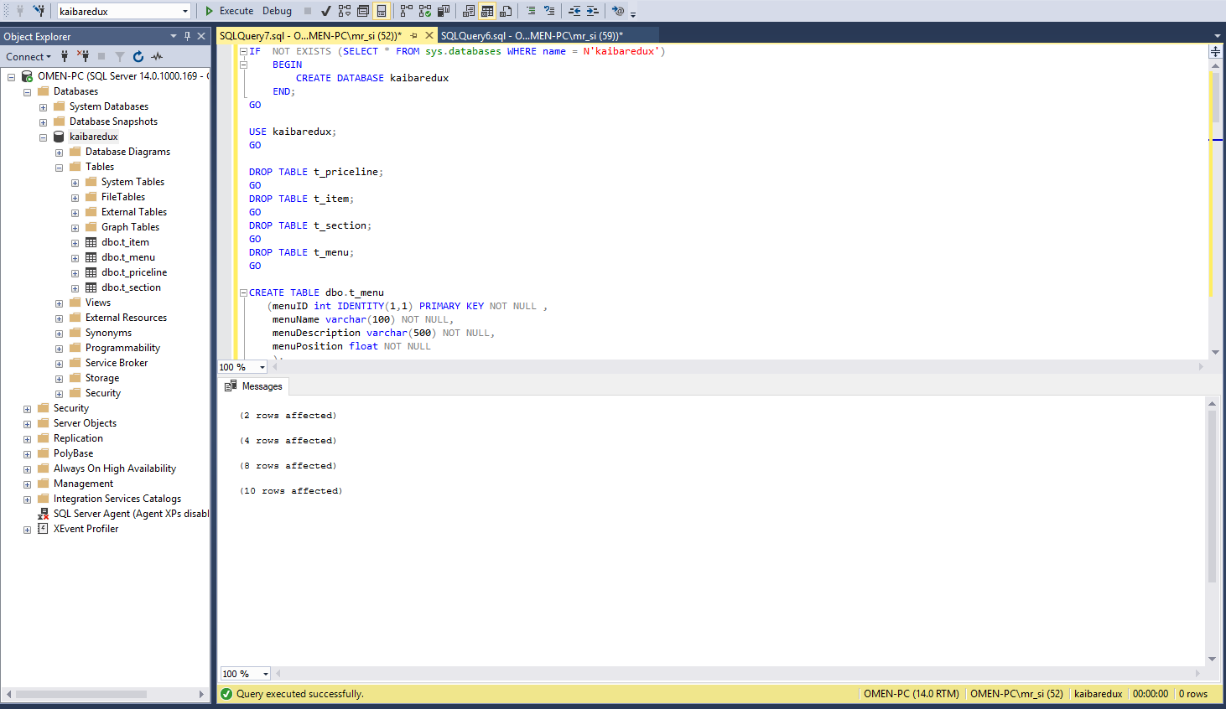

# **4 APPLICATION**

## **4.1 Running the Kaiba Redux API**

Visual Studio starts [**IIS Express**](https://docs.microsoft.com/iis/extensions/introduction-to-iis-express/iis-express-overview) and runs your app when pressed. **Ctrl+F5** (non-debug mode) allows you to make code changes, save the file, refresh the browser, and see the code changes. Also, launching the app in debug or non-debug mode is also optional from the **Debug** menu.

1. Upon running the **“KaibaReduxAPI.sln”** site, security exceptions may need to be granted in Firefox, Chrome, or Edge browsers. Click on the arrow next to **“IIS Express”.** In this demonstration Chrome is preferred.

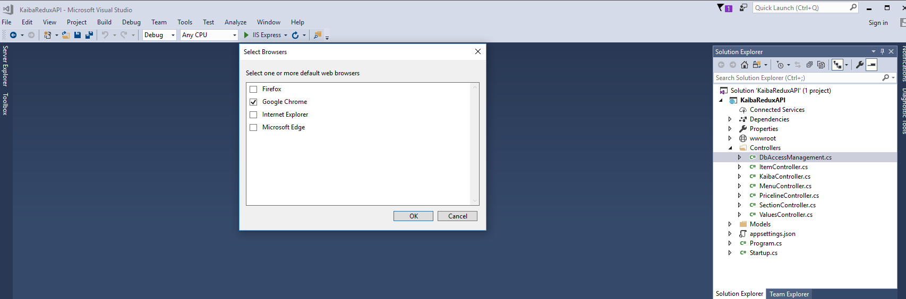

1. Click on **“IIS Express”** to run the **API**
2. A Menu page is displayed with a **“Login”** button that displays the client-side functionality after being pressed.

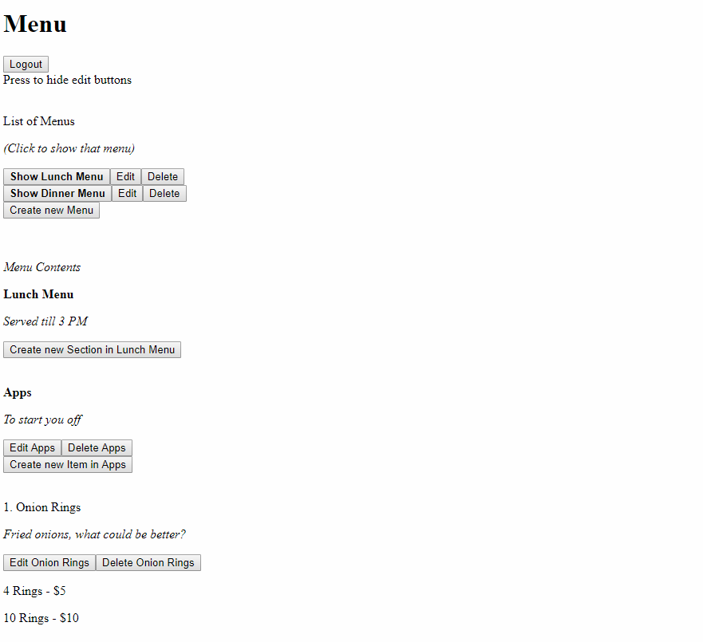

## **4.2 Create a New Menu in the Kaiba Redux API**

1. Click on the **“Create new Menu”** button, enter the following fields in the Create Menu Page and press **“Submit”**
2. The database includes menu name, description and position created on the right (after Executing). The created **Breakfast Menu** (position 0.1.) will be displayed before the **Lunch Menu** (position 1.) in the next section

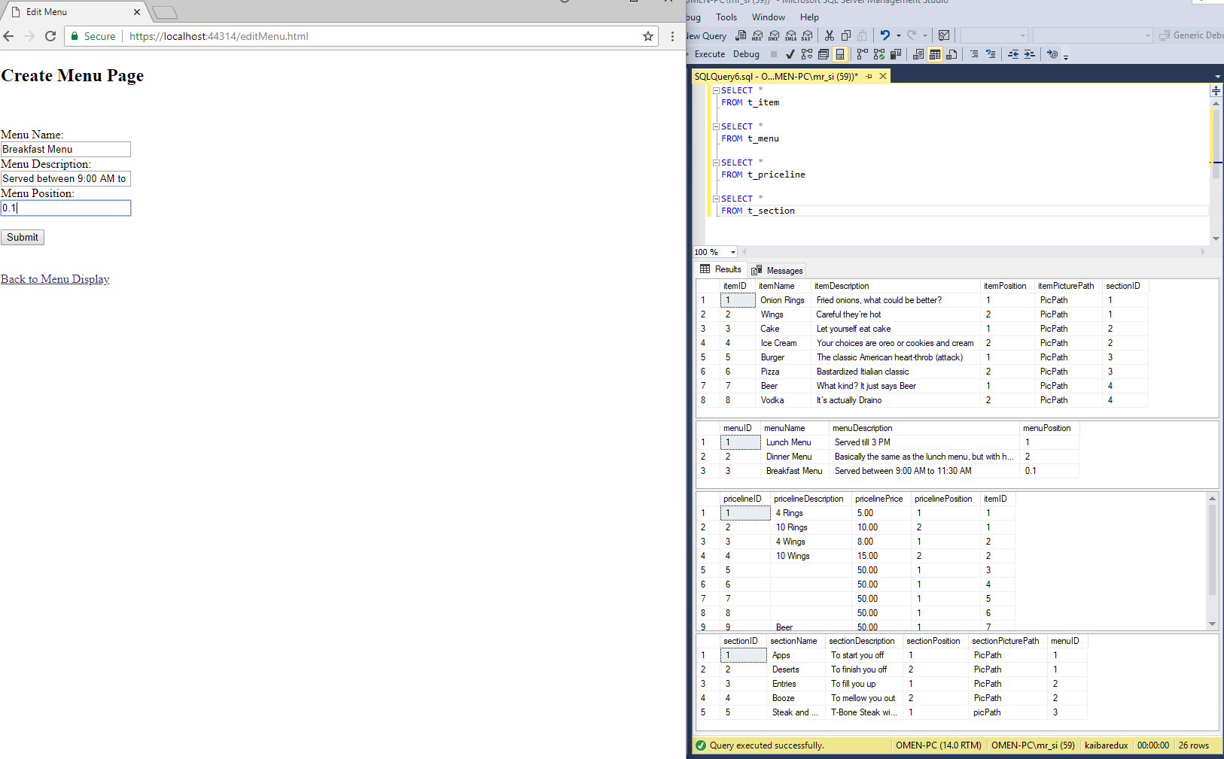

## **4.3 Read a New Menu in the API**

1. Click on **“Show Breakfast Menu”** the created Menu is fetched from SQL Server and displayed in the API along with a newly added section called **“Steak and Eggs”**

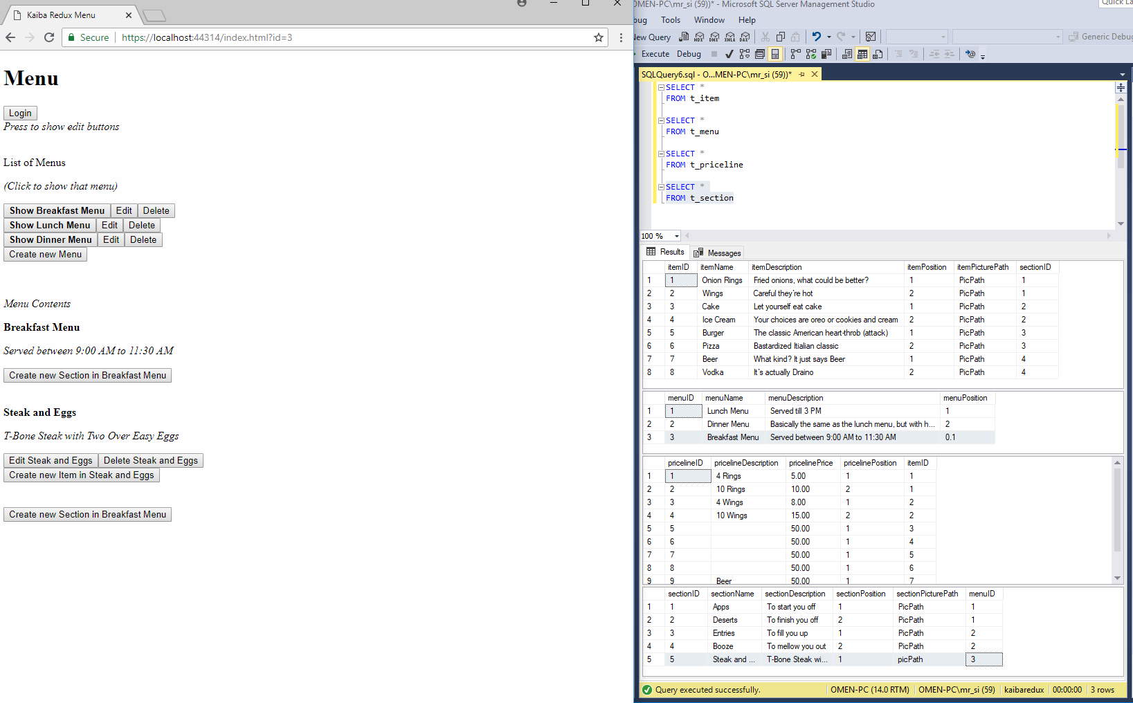

## **4.4 Update and Editing Existing Items**

1. Update the **“Steak and Eggs”** breakfast section by clicking on **“Edit Steak and Eggs”** and renaming it to” Deluxe Steak” to update the existing menu. The changes will be displayed in SQL Server once **“Execute”** is pressed.

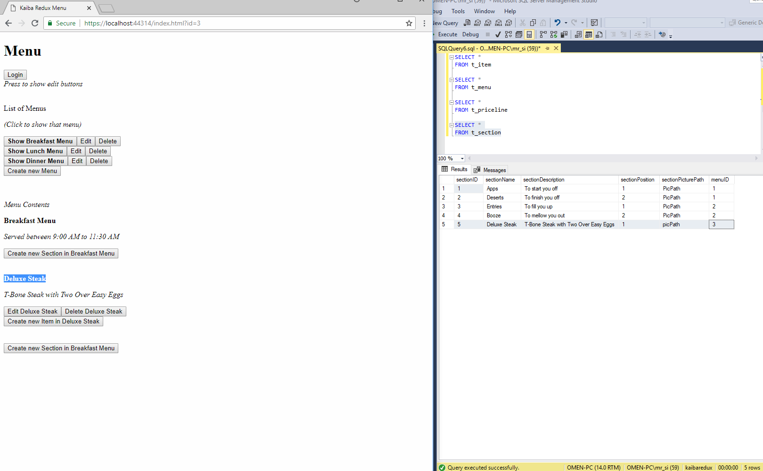

1. Next, edit the “**Deluxe Steaks”** section to just “**Steaks”** and click **“Create new Item in Steaks”**
2. A new item is created in the Steaks Section, click **“Edit T-Bone Breakfast”** and fill the Priceline entities then click **“Submit New Priceline”,** now price can be added/edited.

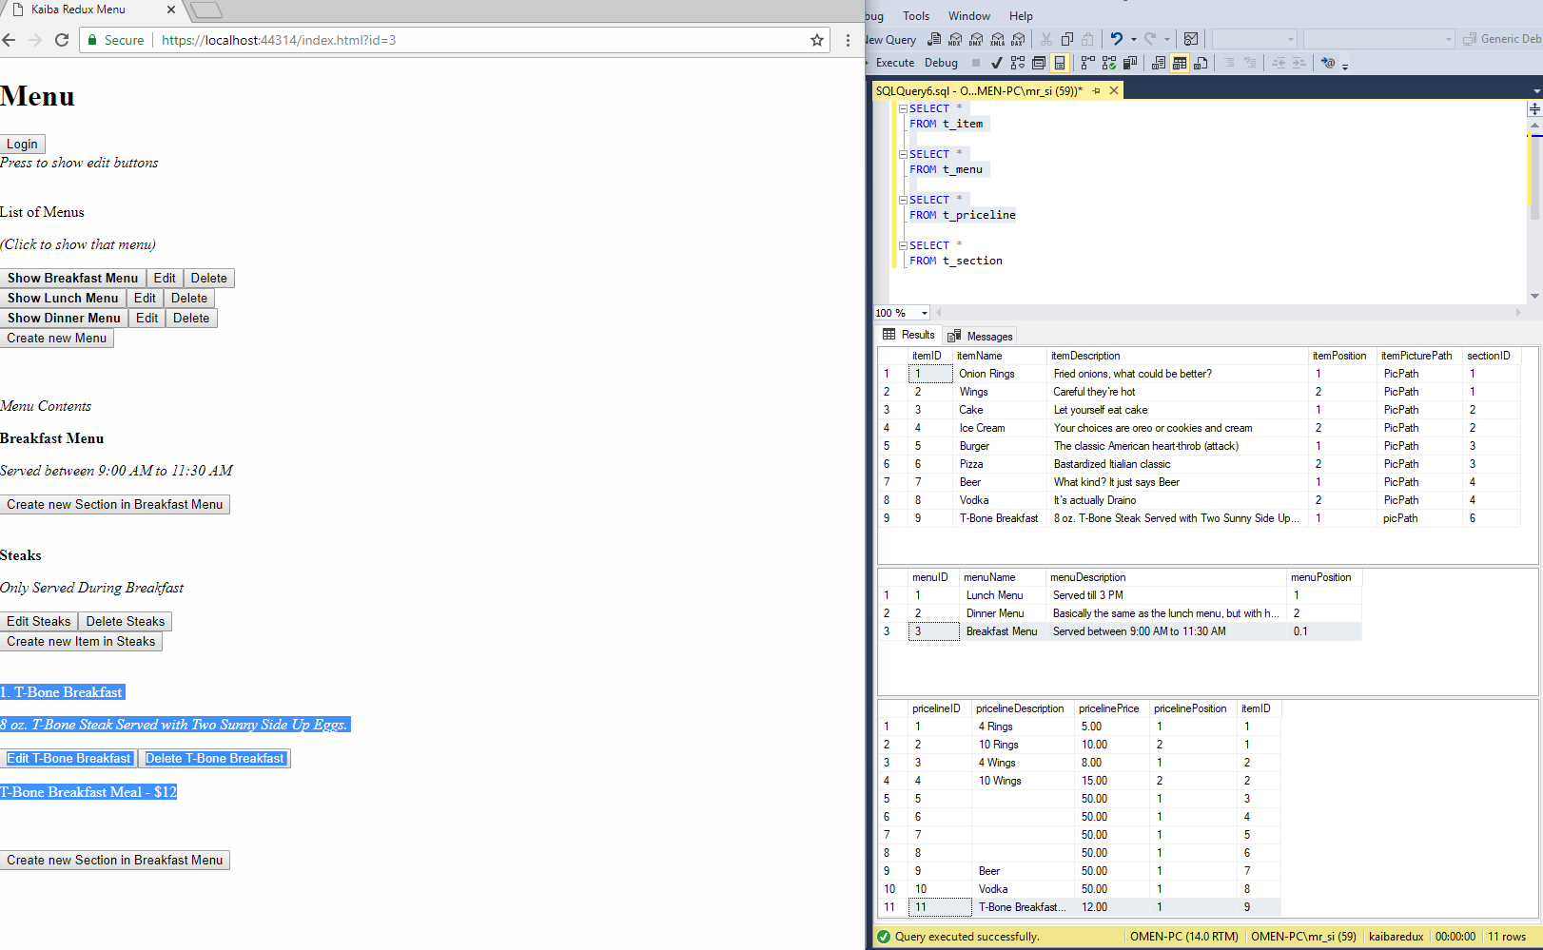

## **4.5 Delete Items from the Application Program Interface**

1. Finally, delete the breakfast menu entirely by clicking on **“Delete”** near **“Show Breakfast Menu”**
2. Accept the confirmation to delete
3. You will see a **“Delete Failed. There are still sections in this menu”**
4. Delete all items within the breakfast menu first, then attempt to delete the entire menu. Refresh the API and the Menu is gone.

